 **27 Feb 2015** **The Weekly Bulletin of Rotary Club of Kathmandu Mid-Town** **bc-33/2.015**

|  |
| --- |
|  |

District: 3292 Web:www.rotarymidtown.org.np Club Id: 26776

**FEBRUARY IS WORLD UNDERSTANDING MONTH**

World Understanding Month is dedicated for

Rotary’s continued quest for goodwill, peace and understanding

among people of the world.

Club’s Weekly Meeting # 1267 on Friday, 20 February:

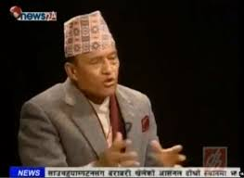

Extracts of the Meeting Minutes :

“1. The Meeting #1267 was called to order.

“7. Pres Kul Chandra welcome guest speaker General Rookmangud Katawal and Rtn Gen

Amar gave the introduction. The General talked about the experiences he has had over

a long and distinguished career but focused on 'My Vision for Nepal'. He set the tone for

his talk by quoting from Pres JF Kennedy, "…..ask not what your country can do for you,

ask what you can do for your country." He went on to explain the democracy is not well

served in Nepal when local elections have not taken place for the past 15-16 years, and

so on. His talk was follows by a lively Q&A session. PP Ambica gave the vote of thanks.

”8. Information sharing:

> 7th District Conference of RI District 3292 on 27th, 28th Feb and 1st Mar, 2015 at Chitwan. District Conference

Committee has been working hard to put together a terrific program that will be informative that will promote “Enjoy Rotary".

> DG Piya has requested the following: You are kindly requested to send the names of those of your Club members interested to be a performer on those two evenings . The Performance could be of any kind like singing songs Folk or Modern, playing any musical instruments like flute , mimicry of any known or unknown personalities or  unique dances. Contact: Harsha Shakya <shakya.harsha@gmail.com..

> A Rotarian from Helsinki, Finland Tuulikki Juusela will be attending the BPW International South Asia Sub Regional Meeting in Kathmandu -- she would like to meet some Rotary members.

“9. Statistics of the meeting: Members present: 24”.

# Weekly Meetings and Programs :

|  |  |  |
| --- | --- | --- |
| Date | Program/ Speaker | Topic of Presentation |
| 27 February | Prof. Tulasi Diwasa (Joshi) | Culture in the context of present day Nepal |
|  |  |  |
|  |  |  |

Weekly Meeting on Friday, 27 February:

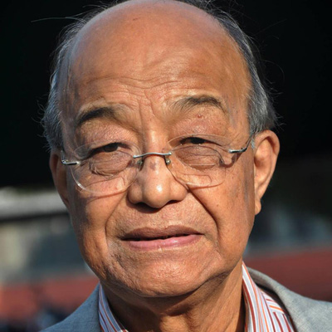

Our guest speaker Prof Tulasi Diwasa is a prominent modernist Nepali poet who belongs to

the group of those poets who introduced experiments, new idioms and novelty in the mode of

expression in the very discourse structure of poetry in Nepali in the sixties and seventies. Born

in Dhankuta, eastern hills of Nepal, Tulasi Diwasa did his MA in Nepali Literature from

Tribhuwan University in 1970.

He did Post-graduate diploma in Folklore & Culture from Tokyo, Japan

Besides, he was Professional Research Associate twice in East-West Centre, Hawai, USA, and

International Visiting Researcher in National Museum of Ethnology, Osaka, Japan.

He is the winner of many academic honours and awards.

He has attended a number of international research seminars, expert meetings, working meetings, conferences and congresses on different aspects of literature, folklore, folk and traditional music, oral traditions, cultural values, rituals of life cycle and intangible cultural heritage in in Nepal, lndia, Japan, Korea, USA, and Europe.

He has published numerous poems and articles in prestigious national and international magazines and journals and has several books on Nepali culture,folklore and literature to his credit.

**A Sad News in the Club:**

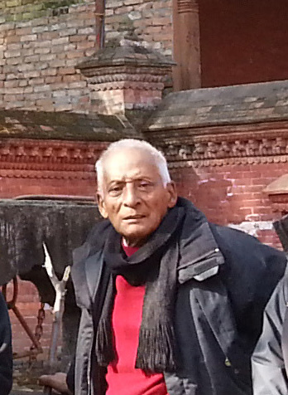

Our Past President Giridhar Lal Manandharis no more with us.

He passed away on Tuesday 24 Feb morning.

May his departed soul rest in peace.

We express our heart-felt condolence to his bereaved family

## 7th District Conference of RI District 3292

## Starts today (Friday, 27 Feb) at Chitwan

## “All the Host Clubs and the organizing committee members in the leadership of Conference Chair Uttam Lal Chuke are eager to welcome you all to this 7th District Conference.

## In addition, also enjoy your fellowships in the flavor and beauty of Chitwan and National Parks.”

## Welcome to Chitwan! : DG Rabindra Piya

**Rota Quiz 2014-15**

Five Finalist Clubs

RC Jawalakhel ⦁ RC Patan Durbar Square ⦁ RC Tripureswor ⦁ RC Itahari ⦁ RC Chitawan

are competing in Rota Quiz Finalon 28 Feb 2015 at Chitwan.

Any guess of winning club?

**Rotary Club of Kathmandu Mid-Town**

Potluck Dinner on Saturday, 28 March 2015

It’s a potluck party and we should have a lot of fun.

The organizers are asking each participant to bring in something, big or small,

so that everyone gets a prize.

Rtn Isabella is currently helping to print the raffle tickets.

Whatever you would like to put it in the prize-pool, it would be better if you notify her

so that she could incorporate it in the raffle ticket.

If you have not yet decided as to what you would be providing,

simply send your entry without mentioning the item.

It would add more fun.

The prize winner will be in suspense as to what is it he/she’s getting!

**Condolence Message of District Governor**

**Dear all,**

**It is with immeasurable grieve in my heart, I share with you all, the news of demise of Rtn. Hikmat Bahadur Mali, Charter President of RC Kathmandu West.**

**A great soul has departed, but the memories shall never fade. Our loss is huge and irreplaceable, and each of us can only share this pain.  He and our memories of him will stay alive in our hearts forever. He was a better man and a true Rotarian. May the soul that has gone rest in peace and let us all pray for the departed soul and his loved ones.**

**Regards,**

**DG Rabindra Piya**

**Air Travel: Fatty People Pay More, and it’s more logical !**

A Samoan airline, that says it is the world's first carrier to charge passengers by their weight rather than per seat, defends the plan as the fairest way to fly, in some cases actually ending up cheaper than conventional tickets. “Passengers are asked to declare their personal weight during booking, which is then charged per kilogram at a rate dependent on flight length. The customers will also be weighed at the check-in counter. This is the concept of the future – the fairest way of travelling," said Samoa Air CEO, Chris Langton. According to Samoa Air's latest schedule, the airline charges up to US$ 0.57 per kg for domestic flights and US$ 1.03 per kg for its only international flight to American Samoa, around 250 miles. Children under 12 are charged 75 percent of the adult rate, with fares also based on weight. Any overweight baggage is calculated at the same rate as the passenger's personal weight.

*Source: The Himalayan Times*

**A THOUGHT FOR TODAY:**

**[Stay away from anger... It hurts ..Only You!](http://www.brainyquote.com/quotes/quotes/b/baruchspin101666.html" \o "view quote)**

**[If you are right then there is no need to get angry,](http://www.brainyquote.com/quotes/quotes/b/baruchspin101666.html" \o "view quote)**

**[And if you are wrong then you don't have any right to get angry!](http://www.brainyquote.com/quotes/quotes/b/baruchspin101666.html" \o "view quote)**

Travel / Tourism

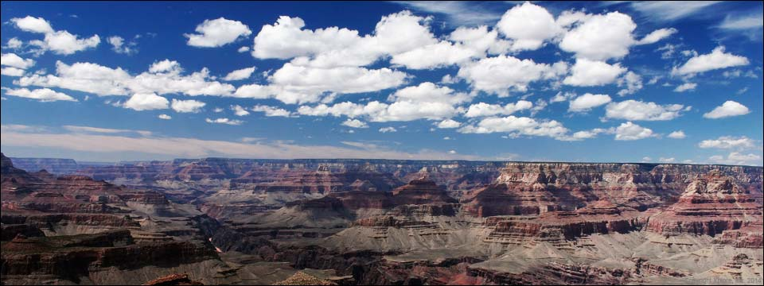

Travelling is a great fun.



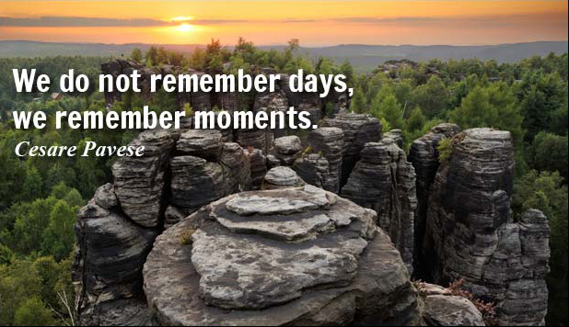

On Lighter Side:

**Behind every successful man is his woman.**

**Behind the fall of a successful man is usually another woman!**

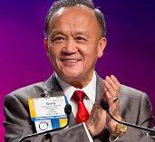

I've heard stories of how our service changes the lives of others, and how it changes us as

Rotarians. When I hear these stories, I can't help but wonder: How many other lives could

we change for the better by bringing more people into Rotary? And how many more people

could we bring into Rotary simply by sharing our own Rotary stories?

**RI President GARY C.K. HUANG**

## 27 February 2015 The Weekly Bulletin of Rotary Club of Kathmandu Mid-Town bc-33/2.015